Homepage
News & Events

An Introduction

October 11, 2007

http://engineering.purdue.edu/

Homepage News & Events

The standard school web sites in the College of Engineering feature news and events on the homepage. These are listed under headings such as Spotlights, News, News & Events, Events, and Initiatives.


Standard School Homepage
with News & Events

The items that appear under these headings are created within a tool called the Purdue Event System. The Purdue Event System provides a special interface within Zope for managing new.

Adding a News Item

Logging In
The first step in adding a news item to your schools homepage is to login. Do this by opening the following URL in your web browser and logging in.

http://engineering.purdue.edu/manage_main

Once you are logged into the editing system (Zope), find the folder for your school and click the associated link.

School Folder Contents
Within your school’s folder you should see several folders and documents. News and Events are maintained within the HomepageFeatures folder. (Note that this folder has a different icon that most other folders).
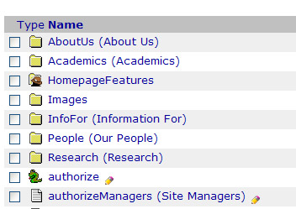
School Folder Contents
Containing a HomepageFeatures Folder

If your school does not have a folder named HomepageFeatures your news may be stored in one of the following locations.

- News/
- Events/
- AboutUs/News/
- AboutUs/Events/

Event Documents Listing
Once you locate your school’s news folder click on the associated link to load the Event Documents screen.

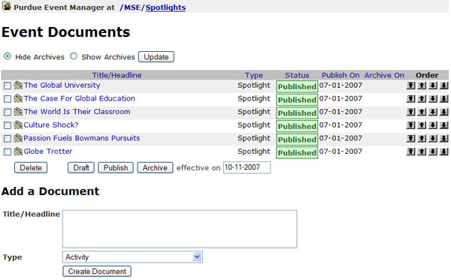
Event Documents Screen

The Event Documents screen lists the current articles displayed on yours site.

Adding a News Item
Below the Event Documents listing is a form titled, “Add a Document”. Provide a Title/Headline and select the appropriate type. The type selected will generally determine where the document appears on your school’s homepage.

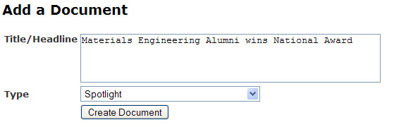
Add a Document Form

After clicking the “Create Document” button the Edit Document form will load.
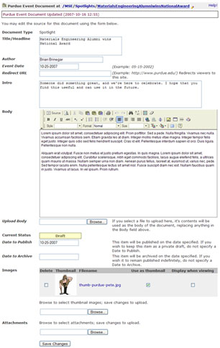

Edit Document Form

The Edit Document form lets you edit all of the information about a news item.

News Item Fields
All News Items have the following fields.

- Title/Headline
- Author – Optional name of the author of the document
- Event Date – Optional date on which this news occurred or will occur
- Redirect URL – Optional web address (URL) where viewers are directed when they attempt to view this document. This can be used to create a “stub” for a news item on your school’s site which links users to an actual store elsewhere.
- Intro – An introduction or summary of the news item. This text is often listed below the title/headline on the school’s homepage
- Body – The content the user should see when viewing the document. If a Redirect URL is specified the body can be left empty.
- Date to Publish – The date on which an event should be displayed to the public.
- Date to Archive – The date on which an event should be moved into the archive.
- Images – Upload images which are used as thumbnails when displaying a news item on the school’s home page. Thumbnails should be square images in JPEG format.
- Attachments – Related files (MS Word, Excel, PDF, etc.) associated with this news item which should be posted with the document.

After completing the necessary fields click the “Save Changes” button at the bottom of the form. If the document is published based on the dates specified it will begin to appear on the school’s homepage.

